Recent trends in nonlinear elliptic equations and nonlinear analysis
会议手册

2015年12月21日-24日
武汉大学数学与统计学院


会议议程
12月21日，星期一，上午 (主持: 陈化)
08:30 – 09:00 | 开幕式及合影
09:00 – 09:50 | 田刚
10:00 – 10:50 | 韩青
10:50 – 11:10 | 茶歇时间
11:10 – 12:00 | 尹景学
午餐

12月21日，星期一，下午（主持：徐超江）
14:00 – 14:50 | 任晓峰
15:00 – 15:50 | 王志强
15:50 – 16:20 | 茶歇时间
16:20 – 17:10 | 王克磊
晚宴

12月22日，星期二，上午（主持：李工宝）
09:00 – 09:50 | 丁彦恒
10:00 – 10:50 | 蒋美跃
10:50 – 11:10 | 茶歇时间
11:10 – 12:00 | 周风
午餐

12月22日，星期二，下午（主持：陈文艺）
14:00 –14:50 | 邹文明
15:00 – 15:50 | 吴雅萍
15:50 – 16:20 | 茶歇时间
16:20 – 17:10 | 李维喜
晚餐

12月23日，星期三，上午（主持：邓引斌）
09:00 – 09:50 | 楼元
10:00 – 10:50 | 周焕松
10:50 – 11:10 | 茶歇时间
11:10 – 12:00 | 郭宗明
午餐

12月23日，星期三，下午（主持：刘晓春）
14:00 – 14:50 | 郭玉霞
15:00 – 15:50 | 段华贵
15:50-16:20 | 茶歇时间
16:20 – 17:10 | 彭双阶
晚餐

12月24日，星期四，上午（主持：魏军城）
09:00 – 09:50 | 曹道民
10:00 – 10:50 | 聂兆虎
10:50 – 11:10 | 茶歇时间
11:10 – 12:00 | 张志涛
午餐

12月24日，星期四，下午
自由讨论

会议地点：武汉大学数学与统计学院数学会堂
用餐地点: 武汉大学珞珈山庄

会议具体议程
2015年12月21日，星期一
上午 (主持:陈化)
08:30-09:00 开幕式及合影
09:00-09:50 田刚
度量空间紧化和复分析
10:00-10:50 韩青
Boundary expansions for certain geometric problems
10:50-11:10 茶歇时间
11:10-12:00 尹景学
Life span for a semilinearheat equation with initial datanon-rarefied at

下午 (主持: 徐超江)
14:00-14:50 任晓峰
Bubbles and droplets in a singular limit of the FitzHugh-Nagumo systems
15:00-15:50 王志强
Synchronization and segregation in coupled nonlinear Schrodinger equations
15:50-16:20 茶歇时间
16:20-17:10 王克磊
The structure of finite Morse index solutions of phase transition models in the plane

2015年12月22日，星期二
上午 (主持: 李工宝)
09:00-09:50 丁彦恒
TBA
10:00-10:50 蒋美跃
The logarithmic Minkowski problem for polytopes
10:50-11:10 茶歇时间
11:10-12:00 周风
Classification of isolated singularities of positive solutions for Choquard equations

下午 (主持: 陈文艺)
14:00-14:50 邹文明
From a Berestycki-Lions theorem to critical Schrodinger equations
15:00-15:50 吴雅萍
Asymptotic behavior of solutions for degenerate Fisher type equations
15:50-16:20 茶歇时间
16:20-17:10 李维喜
Compactness criteria for the resolvent of Fokker-Planck operator

2015年12月23日，星期三
上午 (主持: 邓引斌)
09:00-09:50 楼元
Evolution of diffusion in a mutation-selection model
10:00-10:50 周焕松
Concentration behavior for time independent GP equations
10:50-11:10 茶歇时间
11:10-12:00 郭宗明
Morse index solutions and some related results

下午 (主持: 刘晓春)
14:00-14:50 郭玉霞
Classification of positive solution for Schrodinger system with critical exponent
15:00-15:50 段华贵
The enhanced common index jump theorem for symplectic paths with some applications
15:50-16:20 茶歇时间
16:20-17:10 彭双阶
Existence and local uniqueness of bubbling solutions for poly-harmonic equations

2015年12月24日，星期四
上午 (主持: 魏军城)
09:00-09:50 曹道民
Pohozaev type identities and their application in PDEs
10:00-10:50 聂兆虎
Classification of solutions to Toda systems of types C and B with singular sources
10:50-11:10 茶歇时间
11:10-12:00 张志涛
Existence, symmetry and bifurcation of solutions for Schrodinger systems

下午
自由讨论时间

报 告 摘 要

Pohozaev type identities and their application in PDEs
曹道民（中国科学院数学与系统科学研究院）
TBA.

丁彦恒（中国科学院数学与系统科学研究院）
TBA.

The enhanced common index jump theoremfor symplectic paths
with some applications
段华贵（南开大学）
Recently we have generalized the common index jump theorem proved in 2002 by Long and Zhu to an enhanced version. As applications, we obtained the lower bounds of the total number of distinct closed geodesics on every compact simply-connected rank one symmetric space with a bumpy irreversible Finsler metric under some weak index or curvature conditions, and also got the non-hyperbolicity of these closed geodesics. All these lower bounds are sharp due to Katok's examples on spheres and Ziller's detailed constructions on other rank one symmetric spaces. This is a joint work with Yiming Long and Wei Wang.
Classification of positive solution for Schrodinger system with critical exponent
郭玉霞（清华大学）
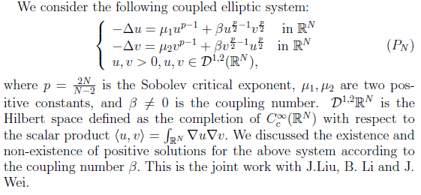
Morse index solutions and some related results
郭宗明（河南师范大学）
We present Liouville type results for weighted elliptic equations with "positive" and "negative" exponents via Morse index. We also give some related results.

Boundary expansions for certain geometric problems
韩青（北京大学& University of Notre Dame）
In some geometric problems, we need to discuss the asymptotic expansions of solutions near boundary and estimate the remainders. The list of such problems includes the singular Yamabe problem, the regularity of minimal surface near the asymptotic infinity in the hyperbolic space and the complete Kahler-Einstein metrics in strictly pseudo-convex domains. Usually, the underlying equations become degenerate along boundary. In this talk, we present a PDE approach for remainder estimates, which are referred to as the polyhomogeneity, and for the global regularity up to boundary.

The Logarithmic Minkowski Problem for Polytopes
蒋美跃（北京大学）
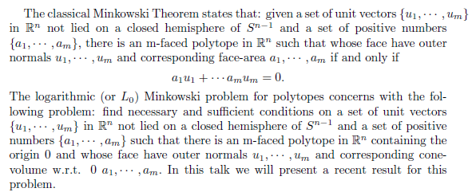
Compactness Criteria for the Resolvent of Fokker-Planck operator
李维喜（武汉大学）
In this talk we study the spectral property of a Fokker-Planck operator with potential. By virtue of a multiplier method inspired by Nicolas Lerner, we obtain new compactness criteria for its resolvent, involving the control of the positive eigenvalues of the Hessian matrix of the potential.

Evolution of diffusion in a mutation-selection model
楼元（人民大学& Ohio State University）
We consider a mutation-selection model of a population structured by the spatial variables and a trait variable which is the diffusion rate. Competition for resource is local inspatial variables, but nonlocal in trait. We show that in the limit of small mutation rate, steady state solutions remain regular in the spatial variables and yet concentrates in the trait variable and forms a Dirac mass supported at the lowest diffusion rate. This is a joint work with King-Yueng Lam (Ohio State University).

Classification of solutions to Toda systems of types C and B
with singular sources
聂兆虎 (Utah State University)
Toda systems are generalizations of the Liouville equation to other simple Lie algebras. For Toda systems of type A, in a fundamental work Lin, Wei and Ye classified their solutions with finite integrals and singular sources at the origin among other results. In this talk, we aim to generalize the classification of solutions to Toda systems of types C and B. Like in the A cases, the solutions are parametrized by corresponding groups. The method is by studying the C and B types as reductions of type A with symmetries. The theories of Toda systems as integrable systems, in particular the W-symmetries and the iterated integral solutions, play essential roles in this work, together with certain characterizing properties of minors of symplectic and orthogonal matrices.

Existence and local uniqueness of bubbling solutions for poly-harmonic equations
彭双阶（华中师范大学）
We will construct infinitely many solutions with infinitely bubbling for a poly-harmonic equation with critical growth. We also give a local uniqueness result for the bubbling solutions, which implies that some bubbling solutions can preserve the symmetry of the equation.

Bubbles and droplets in a singular limit of the FitzHugh-Nagumo systems
任晓峰（The George Washington University）
The FitzHugh-Nagumo system is an activator-inhibitor type reaction-diffusions system, originally proposed to model excitable neurons. In one parameter range, the system is reduced, via the Gamma convergence theory, to ainhibitory geometric problem. We first study this geometric problem on the entire plane for disc solutions, called bubbles. Depending on the two parameters of the problem, one may have zero, one, two, or even three bubbles. Some of these bubbles are stable while others are unstable. Next we build assemblies of perturbed small discs, termed droplets, as stable stationary points of the geometric problem on a bounded domain. This is joint work with Chao-Nien Chen and Yung-Sze Choi.

度量空间紧化和复分析
田刚 （北京大学&Princeton University）
TBA.
The structure of finite Morse index solutions of phase transition models in the plane
王克磊（武汉大学）
Based on the connection between the Allen-Cahn equation and minimal surfaces, many results or conjectures in minimal surface theory have their counterparts in the Allen-Cahn equation. In this talk I will report some recent progress on the structure of finite Morse index solutions of phase transition models in . For two free boundary problems, which are closely related to the Allen-Cahn equation, we show that a finite Morse index solution in has finite ends. Moreover, we can give a very precise description on its asymptotic behavior at infinity.

Synchronization and segregation in coupled nonlinear Schrodinger equations
王志强（天津大学& Utah State University）
We discuss work on existence and qualitative property of positive solutions for coupled nonlinear Schroedinger equations. Depending upon the system being attractive or repulsive synchronized or segregated type solutions can be constructed. We report recent work on the effect of mixed couplings for which coexistence of synchronization and segregation may occur.

Asymptotic Behavior of Solutions for Degenerate Fisher Type Equations
吴雅萍（首都师范大学.）
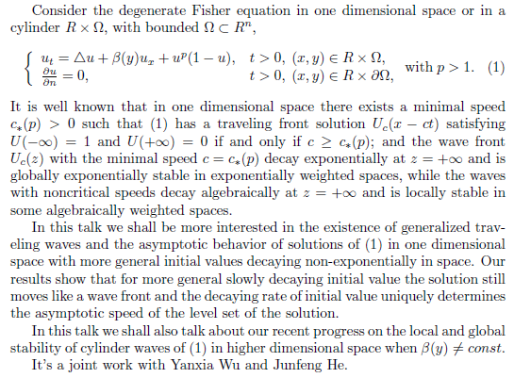

Life Span for a Semilinear Heat Equation with Initial Data non-Rarefied at
尹景学（华南师范大学）
In this talk, we discuss the life span of solutions for the heat equation with nonlinear sources. We will show that as long as the initial datum is non-rarefied at , the solution must blow up at finite time. Moreover, we give a delicate estimate on the life span.
Existence, symmetry and bifurcation of solutions for Schroedinger systems
张志涛（中国科学院数学与系统科学研究院）
We are concerned with the important system of nonlinear Schrodinger equations with linear and (or) nonlinear couplings which arises from Bose-Einstein condensates, we prove phase segregation results of the limit competition case, we use variational methods to prove the existence of ground state and bound state solutions of the systems, and use bifurcation theory to get structure of positive solutions. We also give some partial symmetry results of positive solutions by Morse index etc.

Classification of isolated singularities of positive solutions
For Choquard equations
周风（华东师范大学）
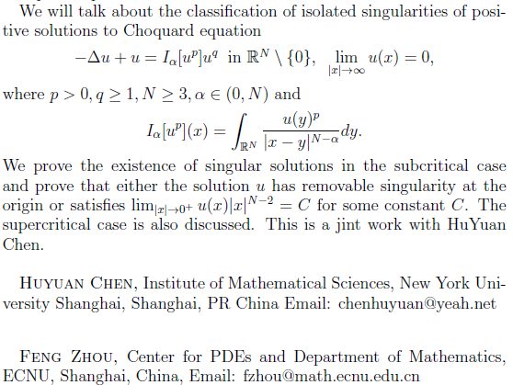

Concentration behavior for time independent GP equations
周焕松（中国科学院武汉物理与数学研究所）
In this talk, we will speak about concentration behavior for time independent Gross-Pitaevskii equations with certain trapping potentials. This talk is based on some joint works with Y.J. Guo，Z.Q. Wang and X.Y.Zeng.

From a Berestycki-Lions theorem to critical Schrodinger equations
邹文明（清华大学）
We generalize a theorem due to Berestycki-Lions and then consider some applications to critical Schroedinger equations.
参会人员

姓名 | 单位 | Email地址
曹道民 | 中国科学院数学与系统科学研究院 | dmcao@amt.ac.cn
陈化 | 武汉大学 | chenhua@whu.edu.cn
陈文艺 | 武汉大学 | wychencn@whu.edu.cn
邓引斌 | 华中师范大学 | ybdeng@mail.ccnu.edu.cn
丁彦恒 | 中国科学院数学与系统科学研究院 | dingyh@math.ac.cn
段华贵 | 南开大学 | duanhg@nankai.edu.cn
郭玉霞 | 清华大学 | yguo@math.tsinghua.edu.cn
郭玉劲 | 中国科学院武汉物理与数学研究所 | yjguo@wipm.ac.cn
郭宗明 | 河南师范大学 | gzm@htu.cn
韩青 | 北京大学& University of Notre Dame | qhan@nd.edu
胡烨耀 | The George Washington University | huyeyao@gwmail.gwu.edu
黄锐 | 华南师范大学 | huang@scnu.edu.cn
黄侠 | 华东师范大学
黄学英 | 武汉大学 | hxyingzi@yahoo.com.cn
蒋美跃 | 北京大学 | mjiang@math.pku.edu.cn
金春花 | 华南师范大学 | jinchhua@126.com
康肖松 | 武汉大学
刘晓春 | 武汉大学 | xcliu@whu.edu.cn
刘念 | 长江大学 | liunian0510@whu.edu.cn
李工宝 | 华中师范大学 | ligb@mail.ccnu.edu.cn
李维喜 | 武汉大学 | wei-xi.li@whu.edu.cn
楼元 | 人民大学 & Ohio State University | lou@math.ohio-state.edu
罗壮初 | 武汉大学 | zhchluo.math@whu.edu.cn
罗鹏 | 中国科学院数学与系统科学研究院 | luopeng@whu.edu.cn
聂兆虎 | Utah State University | zhaohu.nie@usu.edu
彭双阶 | 华中师范大学 | sjpeng@mail.ccnu.edu.cn
任晓峰 | The George Washington University | ren@gwu.edu
孙慧群 | 华南师范大学
沈伟明 | 北京大学
唐岚 | 华中师范大学 | lantang@mail.ccnu.edu.cn
田刚 | 北京大学& Princeton University | tian@math.princeton.edu
田谷基 | 中国科学院武汉物理与数学研究所 | tianguji@wipm.ac.cn
田书英 | 武汉理工大学 | sytian@whu.edu.cn
王克磊 | 武汉大学 | wangkelei@whu.edu.cn
王丽萍 | 华东师范大学 | lpwang@math.ecnu.edu.cn
王涛 | 武汉大学 | tao.wang@whu.edu.cn
王志强 | 天津大学& Utah State University | zhi-qiang.wang@usu.edu
王征平 | 中国科学院武汉物理与数学研究所 | wangzp@wipm.ac.cn
魏军城 | 武汉大学 & Univserity of British Columbia | jcwei@math.ubc.ca
吴雅萍 | 首都师范大学 | yaping-wu@hotmai.com
吴少华 | 武汉大学
徐超江 | 武汉大学 | chjxu.math@whu.edu.cn
杨小舟 | 中国科学院武汉物理与数学研究所 | xzyang@wipm.ac.cn
杨军 | 华中师范大学 | jyang@mail.ccnu.edu.cn
尹景学 | 华南师范大学 | yjx@scnu.edu.cn
曾小雨 | 中国科学院武汉物理与数学研究所 | xyzeng@wipm.ac.cn
张林 | 北京大学
张志涛 | 中国科学院数学与系统科学研究院 | zzt@math.ac.cn
张贻民 | 中国科学院武汉物理与数学研究所 | zhangyimin@wipm.ac.cn
赵会江 | 武汉大学 | hhjjzhao@whu.edu.cn
周焕松 | 中国科学院武汉物理与数学研究所 | hszhou@wipm.ac.cn
周小方 | 武汉大学 | xfzhou.math@whu.edu.cn
邹文明 | 清华大学 | wzou@math.tsinghua.edu.cn
程峰 | 武汉大学
陈鹏 | 武汉大学
樊迎哲 | 武汉大学
谷龙江 | 中国科学院武汉物理与数学研究所
郭合林 | 中国科学院武汉物理与数学研究所
郭伦 | 华中师范大学
何躏 | 武汉大学
何其涵 | 华中师范大学
胡亭曦 | 华中师范大学
胡鑫 | 武汉大学
黄文涛 | 华中师范大学
黄炳康 | 武汉大学
罗肖 | 华中师范大学
李帅 | 中国科学院武汉物理与数学研究所
吕文斌 | 武汉大学
帅伟 | 华中师范大学
唐少君 | 武汉大学
汤士强 | 武汉大学
涂强 | 武汉大学
危苏婷 | 华中师范大学
王楚 | 北京大学
王庆芳 | 华中师范大学
王文波 | 中国科学院武汉物理与数学研究所
张栋 | 北京大学
詹金鹏 | 武汉大学
朱新才 | 中国科学院武汉物理与数学研究所
周一夫 | 武汉大学
左碧君 | 中国科学院武汉物理与数学研究所

